BONAFIDE CERTIFICATE

Certified that this report titled “EXITEASE – A CHATBOT BASED OUTPASS GENERATOR” is the bonafide work of “AKARSHANA S (714023247003), ATHULYA A M (714023247008), GOPIKA A S (714023247014), NEHA S (714023247054)“, who carried out the project work under our supervision.

SIGNATURE SIGNATURE

Mrs. S. Hemalatha Mrs. N. Gayathri

HEAD OF THE DEPARTMENT SUPERVISOR

Artificial Intelligence and Artificial Intelligence and

Machine Learning. Machine Learning.

Sri Shakthi Institute of Engineering Sri Shakthi Institute of Engineering

and Technology, and Technology,

Coimbatore – 641 062 Coimbatore – 641 062

Submitted for the project work Viva Voice Examination held on ………………..

INTERNAL EXAMINER EXTERNAL EXAMINER

ACKNOWLEDGMENT

First and foremost, I would like to thank God Almighty for giving me strength Without his blessings, this achievement would not have been possible.
We express our deepest gratitude to our Chairman Dr. S. Thangavelu for his continuous encouragement and support throughout our course of study.
We are thankful to our Secretary Dr.T.Dheepan for his unwavering support during the entire course of this project work.
We are also thankful to our Joint Secretary Mr. T. Sheelan for his support during the entire course of this project work.
We are highly indebted to Principal Dr. N. K. Sakthivel for his support during the tenure of the project.
We are deeply indebted to our Head of the Department, Artificial Intelligence and Machine Learning. Mrs.S.Hemalatha, for providing us with the necessary facilities.
It's a great pleasure to thank our Project Guide Mrs. N. Gayathri for her valuable technical suggestions and continuous guidance throughout this project work. We solemnly extend our thanks to all the teachers and non-teaching staff of our department, family, and friends for their valuable support.

AKARSHANA S | (714023202003)
ATHULYA A M | (714023202008)
GOPIKA A S | (714023202014)
NEHA S | (714023202054)

ABSTRACT

In many educational institutions, the management of student outpass requests remains a slow and manual process, often involving physical approvals and fragmented communication. This results in delays, confusion, and a lack of transparency in tracking student movement. Additionally, verifying whether a student has proper authorization to leave or re-enter the campus is a challenge for security personnel, especially during emergencies. To address these issues, this project introduces an intelligent and automated Outpass Generator Chatbot System that allows students to request outpasses through a user-friendly chatbot interface. The chatbot collects necessary details such as reason, duration, and emergency status, and forwards the request through a structured four-level approval workflow. Each stage includes real-time notifications and the ability for approvers to provide justifications for acceptance or rejection. A unique feature of this system is its advanced security verification method. Instead of using paper-based passes or QR codes, the security team can upload a live photo of the student at the gate, and the system uses facial recognition to identify the student, retrieve their roll number, and cross-check it against the database to confirm outpass validity. This ensures secure and contactless verification of student movement. Built using Flask for the backend, MongoDB for database management, and integrated with facial recognition technology, the system significantly improves efficiency, security, and accountability in the outpass approval and verification process.

TABLE OF CONTENTS

CHAPTER NO | TITLE | P. NO
 | ACKNOWLEDGEMENT | iii
 | ABSTRACT | iv
 | LIST OF FIGURES | vi
1 | INTRODUCTION | 01
2 | LITERATURE REVIEW | 03
 | 2.1 HISTORICAL CONTEXT | 03
 | 2.2 INITIATIVE ASPECT | 03
 | 2.3 CURRENT SCENARIO | 03
3 | EXISTING METHOD | 04
 | 3.1 DISADVANTAGES | 04
4 | PROPOSED METHOD | 07
 | 4.1 ADVANTAGES | 07
5 | SYSTEM ANALYSIS | 10
 | 5.1 SOFTWARE REQUIREMENTS | 10
6 | DESIGN AND IMPLEMENTATION | 12
 | 6.1 WORK FLOW | 12
 | 6.2 SYSTEM ARCHITECTURE | 12
 | 6.3 IMPLEMENTATION | 13
7 | RESULT AND ANALYSIS | 17
 | 7.1 LOGIN PAGE | 17
 | 7.2 STUDENT DASHBOARD | 17
 | 7.3 APPROVER DASHBOARD | 18
 | 7.4 SECURITY DASHBOARD | 19
8 | CONCLUSION AND FUTURE ENHANCEMENT | 20
 | 8.1 CONCLUSION | 20
 | 8.2 FUTURE ENHANCEMENT | 20
 | REFERENCES | 21

LIST OF FIGURES

FIGURE NO | DESCRIPTION | PAGE NO
6.1.1 | WORK FLOW | 12
7.1.1 | LOGIN PAGE | 17
7.2.1 | SECURITY DASHBOARD | 18
7.3.1 | APPROVER DASHBOARD | 19
7.4.1 | STUDENT DASHBOARD | 19

CHAPTER 1 INTRODUCTION

The Outpass Generator Chatbot System for Educational Institutions is a web-based application designed to streamline and modernize the process of managing student outpass requests. In most colleges and universities, students must obtain permission from multiple authorities to leave the campus temporarily. This process is traditionally managed through paper-based applications or informal verbal approvals, leading to inefficiencies, communication gaps, and poor tracking of student movement. Moreover, during emergency situations or peak times, the manual system fails to respond quickly, putting students at a disadvantage and increasing the workload for staff and security personnel. This project aims to eliminate these issues by offering a centralized, automated, and intelligent platform that handles the entire outpass workflow—from request generation to approval and final verification at the campus gates.

The system is developed to meet the specific needs of different user roles, including students, approvers (such as class advisors, department heads, and wardens), administrators, and security personnel. Students can easily initiate outpass requests by chatting with a user-friendly chatbot interface, where they provide relevant information such as the reason for the outpass, duration, and whether it is a regular or emergency request. The chatbot ensures that all required details are collected and then forwards the request through a structured, multi-level approval process. Each approver in the workflow receives notifications, reviews the request, and either approves or rejects it with appropriate justification. The students are kept informed of the status at each stage, fostering transparency and timely communication.

A standout feature of the system is its facial recognition-based identity verification. Instead of relying on physical documents or traditional QR code scanning, the security personnel at the gate can upload a live photo of the student. The system then uses facial recognition technology to identify the student, retrieve their roll number, and cross-reference it with the database to verify whether they have a valid outpass for that specific time. This ensures that only authorized individuals are allowed to leave or enter the campus, significantly enhancing institutional security. The backend is built using Flask, a lightweight Python framework, and MongoDB, a NoSQL database optimized for scalable and efficient data storage.

The system is designed to handle both normal and emergency outpass scenarios. For urgent situations, the approval process is fast-tracked, allowing students to receive quicker responses without compromising security or protocol. The chatbot also provides clear updates at every step, reducing ambiguity for students and improving communication. Additionally, the platform keeps a record of past requests and approvals, which can be used by administrators to analyze trends and maintain logs for accountability.

Accessibility and usability are central to the system's design. The interface is responsive and mobile-friendly, enabling users to access it from desktops, tablets, or smartphones. Each user role has a clearly defined dashboard and access permissions, ensuring data privacy and ease of navigation. By automating repetitive tasks such as request tracking and notification delivery, the system reduces administrative workload and improves overall operational efficiency.

Beyond simplifying student movement management, the Outpass Generator Chatbot System also lays the groundwork for digital transformation within campus administration. By leveraging automation, AI-driven facial recognition, and real-time communication, the system reduces dependency on manual labor and paper-based workflows. It creates a secure digital trail of all activities, which can be valuable for audits, behavioral analysis, and policy improvement. Moreover, the modular architecture of the system allows it to be extended or integrated with other institutional platforms, such as attendance monitoring, hostel management, or academic scheduling systems. With its emphasis on efficiency, accuracy, and user experience, this system not only addresses an immediate operational challenge but also contributes to the broader vision of creating a smarter, safer, and more responsive educational environment.

CHAPTER 2 LITERATURE REVIEW

2.1 HISTORICAL CONTEXT
Initially, educational institutions relied on manual, paper-based methods for handling student outpass requests. Students were required to fill out handwritten forms and seek multiple approvals from class advisors, department heads, and wardens. This process was time-consuming, inefficient, and prone to delays, especially during peak periods or emergencies. The lack of centralized tracking also led to issues like unauthorized movements, missing records, and poor communication between departments. Security personnel at campus gates had no real-time way of verifying student permissions, increasing the chances of manual errors or security breaches.
2.2 INITIATIVE ASPECT
With the growing student population and increasing need for accountability, institutions began exploring digital solutions. Initial attempts involved simple Google Forms or spreadsheets, which were easy to set up but lacked automation, security, and multi-level approval workflows. Recognizing the need for a more intelligent system, the initiative to build a chatbot-driven outpass platform emerged. This approach combined ease of use with intelligent workflow management, allowing students to request outpasses via a chat interface. The system also introduced role-based dashboards for approvers and integrated facial recognition for identity verification, replacing traditional QR-based systems and enhancing gate security.

2.3 CURRENT SCENARIO
Today, the Outpass Generator Chatbot System represents a modern, web-based solution that streamlines the entire outpass process. Students can initiate requests via chatbot, and the system automatically forwards them through multiple approval levels while providing real-time status updates. Approvers can review requests from their dashboards and respond quickly with justifications. Instead of using printed outpasses or QR codes, security personnel upload a photo of the student at the gate; the system uses facial recognition to validate their identity and outpass status. The system stores all historical requests, supports emergency fast-track approvals, and minimizes manual effort. With modular design, secure access control, and future-ready integration capabilities, the platform significantly improves operational efficiency, transparency, and campus security.

CHAPTER 3

EXISTING METHOD

In most educational institutions, the current process for handling student outpass requests is entirely manual and paper-based. Students are required to fill out physical request forms and submit them for approval to multiple authorities, such as class advisors, department heads, and wardens. This sequential process is time-consuming and depends heavily on the physical presence and availability of each approver. Tracking the status of an application is difficult, and students often face delays due to missing signatures, miscommunication, or the unavailability of staff. In many cases, forms are lost or mishandled, resulting in students being unable to leave campus as planned. Furthermore, once approved, these paper outpasses must be presented at the security gate, where guards manually verify signatures and details. This lack of a real-time digital record increases the chances of unauthorized access and misuse, posing a risk to campus safety. The entire workflow is inefficient, untrackable, and lacks transparency for both students and staff.

3.1 DISADVANTAGES

The existing student outpass system relies on manual registers or simple online forms, causing delays and inefficiencies. It lacks automation, real-time tracking, and proper approval flow. The process is prone to errors, miscommunication, and lacks proper data security. These limitations highlight the need for a smart, automated outpass management system.
3.1.1 Time-consuming process
The current manual method requires students to physically visit each approver for their signature, sometimes waiting for hours due to class timings or staff unavailability. This leads to a significant waste of time and energy, disrupting academic schedules..
3.1.2 Prone to Human Error
Data such as student name, roll number, time, and reason are handwritten, it is easy for mistakes to occur. Misread handwriting or incorrect entries can cause delays or result in wrongful approvals or rejections. There is no validation mechanism to check the accuracy of submitted details.
3.1.3 No Centralized Tracking
There is no digital platform where students or staff can track the approval status of a request. A student has no way of knowing whether their application is still pending or rejected without directly contacting each approver. This leads to frustration and communication gaps.
3.1.4 Lack of transparency
Without a tracking system or alerts, students don’t know if their request is progressing or being held up. They are often forced to follow up in person, which is inefficient and causes repeated interruptions for both students and staff.
3.1.5 Security Risks
Since the outpasses are paper-based, they are easy to fake, tamper with, or reuse. There is no digital verification step at the security gate, which can lead to unauthorized exits and safety concerns within the institution.
3.1.6 No emergency handling
All requests, whether routine or emergency, go through the same lengthy process. There is no system in place to fast-track approvals during critical situations like medical emergencies or urgent family matters, which puts students at risk.
3.1.7 Poor Scalability
As the student population grows, managing thousands of outpass requests manually becomes chaotic. Paper registers fill up quickly, and tracking approvals becomes even more difficult. Larger institutions find this method unmanageable.
3.1.8 Inconsistent Process
Different departments or hostels may follow slightly different approval steps, leading to confusion among students. Some staff may be lenient, others strict, creating inconsistency and possible favoritism in how approvals are handled.
3.1.9 High Administrative Workload
Faculty and staff spend a significant amount of time reviewing, signing, and recording requests, often during their busy schedules. This reduces their time for teaching or administrative planning, resulting in inefficiency and burnout.
3.1.10 No Historical Data
There is no organized archive of past outpass records. If a security concern arises, it is difficult to trace student movements or analyze patterns. This limits the institution’s ability to make informed decisions or spot unusual leave behavior.
3.1.11 Lack of Communication
Students do not receive notifications about their request status, and in case of rejection, they often don’t know the reason. This leads to confusion, repeat requests, and frequent misunderstandings between students and staff.
3.1.12 No Access Control
There is no system to control who can view or alter the outpass requests. Sensitive data like medical reasons or personal issues are written openly and can be seen or mishandled by anyone with access to the register.
3.1.13 Lack of Automation
Every step in the current process is manually handled—from form filling and verification to approval and security validation. This lack of automation leads to bottlenecks, increased approval times, and unnecessary burden on staff.

These disadvantages emphasize the urgent need for a more intelligent, automated, and centralized outpass management system that can streamline approvals, enhance security, provide real-time tracking, and reduce the burden on both students and staff.

CHAPTER 4

PROPOSED METHOD

The Outpass Generator Chatbot System is a smart, web-based platform developed to automate and simplify the student outpass request and approval process in educational institutions. Built using Flask (backend), MongoDB (database), and HTML, CSS, JavaScript (frontend), it includes a rule-based chatbot that allows students to request outpasses interactively, check status, and receive notifications.

The system supports four key roles: Student, Approver, Admin, and Security. Students can request outpasses, check leave history, and get real-time updates. Approvers (Class Incharge, HOD, Warden) can view and manage requests with options to approve, reject with justification, or fast-track emergencies. Admins handle system-wide controls like user management, deadline setting, and report generation. The Security role verifies QR codes of approved outpasses at the exit point to ensure safety and track movement.

Role-based access control (RBAC) ensures each user can access only relevant functions and data, maintaining privacy and security. The system replaces paper-based approvals and unstructured forms with an organized, automated flow. It includes smart features like auto-rejection on deadline lapse, emergency alerts, live tracking, and approval stage notifications via email or SMS.

The portal is scalable, reliable, and time-saving, reducing manual workload while improving accountability, transparency, and operational efficiency within institutions.

ADVANTAGES

The Outpass Generator Chatbot System offers a modern, automated solution to streamline the student leave request and approval process. It overcomes the inefficiencies of manual paper-based systems and enhances communication, tracking, and security.

    - Automation and Workflow Management
The system automates outpass request generation and approval, removing the need for manual paperwork and physical signatures. Students can initiate requests via a chatbot, and the system routes them to designated approvers in a predefined order. This ensures requests are processed smoothly and systematically.
    - Role Based Access Control (RBAC)
Each user type (Student, Approver, Admin, Security) is assigned specific roles with limited access based on their permissions. This structured access control protects sensitive data, ensures accountability, and reduces the chance of unauthorized modifications.
    - Email Notifications for Transparency
The system sends automated email notifications at each stage of the outpass process—submission, approval, rejection, or auto-rejection. This keeps students and approvers informed without needing separate communication tools and reduces confusion or miscommunication.
    - Intelligent Leave filtering
The system sends automated email notifications at each stage of the outpass process—submission, approval, rejection, or auto-rejection. This keeps students and approvers informed without needing separate communication tools and reduces confusion or miscommunication.
    - Centralized Dashboard for Approvers
Approvers and admins use a unified dashboard to view, filter, and manage all requests. This centralized control improves tracking, speeds up decision-making, and offers visibility over request history, reducing the need for back-and-forth clarification.
    - Simple Chatbot Interface for Students
Designed The chatbot interface allows students to apply for outpasses through a guided conversation. This minimizes form-filling errors, reduces complexity, and makes the system easy to use even for students with limited technical knowledge.
    - Enhanced Accuracy and Auditability
Every action in the system—submissions, decisions, and timestamps—is recorded for future reference. This complete audit trail supports transparency, enables easy reporting, and reduces the chances of lost or misplaced requests.
    - Time and Resource Efficiency
By By digitizing and automating the outpass process, the system significantly reduces the workload on faculty, admin staff, and students. It eliminates delays caused by physical form circulation and follow-ups, allowing approvers to act faster and institutions to operate more efficiently with fewer manual interventions.

    - Integration with Institutional Workflow
The Outpass Generator Chatbot is seamlessly integrated into the institution’s workflow, aligning with existing approval hierarchies and leave policies. Approvers at each level can view, filter, and manage requests through a dedicated dashboard, streamlining communication and ensuring that every request follows the proper channel before final approval. This integration reduces administrative burden and improves coordination across departments.
    - Transparency and Tracking
The system ensures transparency by allowing students to track the status of their outpass requests in real time. Each stage of approval is recorded, and email notifications are sent automatically during approvals or rejections. This creates a clear communication trail and builds accountability among both students and approvers.

These advantages make the Outpass Generator Chatbot a reliable, efficient, and scalable solution that streamlines the leave approval workflow, reduces manual processing errors, enhances data privacy, and improves communication within the institution. It stands out as a preferred alternative to traditional paper-based or email-based systems, offering a modern, integrated platform tailored to meet institutional needs effectively.

CHAPTER 5

SYSTEM ANALYSIS

The Outpass Generator is a modern, web-based application designed to simplify and automate the student outpass request and approval process in educational institutions. It utilizes a combination of technologies including HTML, CSS, JavaScript, Flask, and MongoDB to provide a reliable, efficient, and user-friendly platform. The system ensures secure role-based access, automated notifications, and streamlined workflows for students, approvers, and administrators. Below is an overview of how each technology is used in the system.

5.1 SOFTWARE ﻿REQUIREMENTS

5.1.1 HTML (HyperText Markup Language)
HTML is used to create the structural layout of the web pages such as the outpass request form, login page, and approval dashboard. It defines elements like input fields, buttons, tables, and forms, enabling users to interact with the system.

5.1.2 CSS (Cascading Style Sheets)
CSS styles the HTML content to provide a visually appealing and responsive design. It ensures that the portal is user-friendly and consistent in appearance across various devices like desktops, tablets, and smartphones..

5.1.3 JavaScript
JavaScript is used to add interactivity and real-time feedback to the portal. It enhances user experience by performing functions like form validation, updating status dynamically, and handling client-side interactions without needing page reloads..

5.1.4 Flask (Python-based Web Framework)
Flask is a lightweight and powerful Python web framework used to build the backend of the portal. It handles HTTP requests, routes, and server-side logic, including data processing and report generation. Flask is chosen for its simplicity and flexibility, allowing developers to quickly build and scale the application. It handles user authentication, role-based access control (RBAC), and processes business logic related to the outpass generation.

5.1.5 MongoDB (NoSQL Database)
MongoDB serves as the primary database system for the Outpass Generator. It is a document-based NoSQL database that stores data in BSON (Binary JSON) format. MongoDB is ideal for the project due to its flexibility, allowing the storage of different types of user data like student details, request history, approval timestamps, and role-specific records. It supports quick read/write operations, enabling smooth performance even when handling multiple requests simultaneously. With MongoDB, the application can easily scale to accommodate a growing number of users, and it allows for efficient filtering of requests based on criteria like date, role, or status.

5.1.6 Flask-Mail
Flask-Mail is an email extension for Flask that allows the Outpass Generator to send automated email notifications. It is used to notify students when their requests are approved, rejected, or pending, and to alert approvers when new requests are submitted. Flask-Mail supports various email servers and allows customization of message content, subject lines, and recipient lists. It ensures timely communication between users and helps maintain transparency in the approval workflow. Integration with Flask makes it simple to trigger emails at specific points in the application logic, such as after form submissions or status changes.

CHAPTER 6

DESIGN AND IMPLEMENTATION

6.1 WORK FLOW

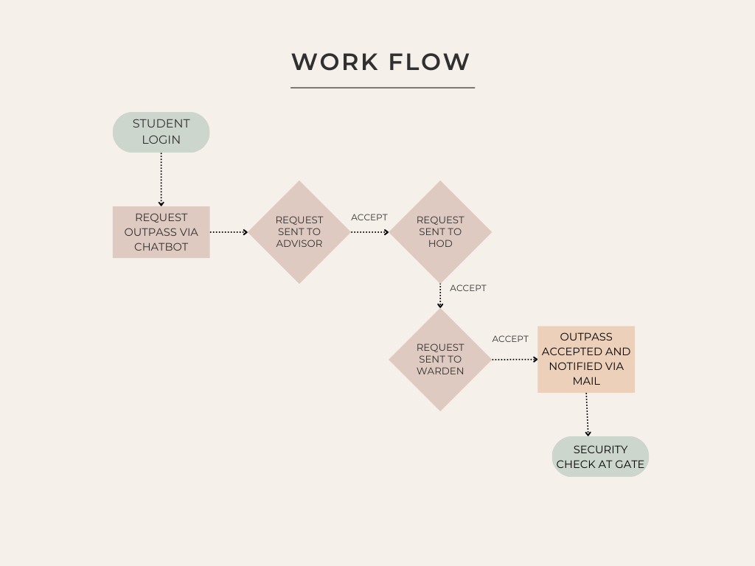
The workflow of the outpass generator chatbot begins with the student logging into the system and submitting a request through the chatbot interface. The request is first sent to the advisor for initial approval. Upon acceptance, it moves to the Head of Department (HOD) for secondary verification. Once approved by the HOD, the request is forwarded to the warden for final clearance. If all three authorities approve, the outpass is marked as accepted and the student is notified via email. The student can then proceed to the gate, where the security team verifies the approval for exit.

Figure 6.1.1 Work Flow

6.2 SYSTEM ARCHITECHTURE

6.2.1 Frontend Layer
The frontend layer consists of three main interfaces: the Chatbot Interface, Web Dashboard, and Security Interface. The Chatbot Interface enables students to initiate and track their outpass requests by interacting in a user-friendly conversational format. The Web Dashboard is accessed by different approvers—Advisor, HOD, and Warden—who can view request details, approve or reject them, and add remarks if needed. The Security Interface is specifically designed for gate staff, allowing them to verify approved requests and capture the student's photo during exit for security purposes.

6.2.2 Backend Layer
The backend layer is powered by a Flask server that handles all core functionalities, including routing, form submissions, and API interactions. It includes an Authentication Module to manage secure login and role-based access for students, approvers, and security staff. The Approval Workflow Module ensures that each outpass request follows the correct sequence through all approvers. The Notification Module is responsible for sending alerts to students about their request status via email.Additionally, the Photo Capture Module manages image capture at the security gate and stores it in the database.

6.2.3 Database Layer
The database layer uses MongoDB to store and manage all the system’s data. This includes user credentials, outpass request details, approval logs, timestamps, and captured photos. The structure ensures quick retrieval of data for real-time updates and maintains an audit trail for all actions taken within the system.

6.2.4 Security Layer
The security layer provides final verification at the institution's exit point. It validates whether a student’s outpass has been approved by all authorities. Once verified, the system captures the student’s photograph using a connected camera and stores it along with a timestamp for record-keeping. This additional step enhances security and accountability.

6.3 IMPLEMENTATION
The ExitEase Outpass Generator system was implemented using a three-tier architecture: the Chatbot Interface, Web Dashboard, and Security Module. The backend was built using the Flask web framework, chosen for its lightweight structure and ease of integration with RESTful APIs. MongoDB was used as the primary database to store user information, outpass requests, approval logs, and security data.

The Chatbot Interface allows students to initiate outpass requests through a simple, guided conversation. Once the student submits their reason, date, and time for leave, the data is collected and stored in the database with a “Pending” status. A sample backend route to handle this request is shown below:
@app.route('/process_outpass/<outpass_id>', methods=['POST'])
@login_required
def process_outpass(outpass_id):
try:
action = request.form.get('action')
user = get_user_by_username(session['username'])
user_role = user.get('role')
if not action:
flash('Action is required.', 'error')
return redirect(url_for('dashboard'))
outpass = outpasses_collection.find_one({"_id": ObjectId(outpass_id)})
if not outpass:
flash('Outpass request not found.', 'error')
return redirect(url_for('dashboard'))
roll_number = outpass.get('roll_number')
student = users_collection.find_one({"roll_number": roll_number})
student_email = student.get('mail') if student else None
if not student_email:
flash('Student email not found. Unable to send notification.', 'error')
return redirect(url_for('dashboard'))
if action == "Accepted":
new_status = f"Accepted by {user_role}"
if user_role == "warden":
qr_code_data = {key: str(value) for key, value in outpass.items()}
qr_code_path = generate_qr_code(qr_code_data)
subject = "Your Approved Outpass with QR Code"
message = (
f"Dear {student.get('name')},\n\n"
f"Your outpass request has been approved by the Warden.\n\n"
f"Please find the attached QR code containing your outpass details.\n\n"
f"Thank you."
)
send_email_with_attachment(student_email, subject, message, qr_code_path)
flash(f'QR code sent to {student_email}.', 'success')
else:
subject = "Outpass Request Accepted"
message = (
f"Dear {student.get('name')},\n\n"
f"Your outpass request has been accepted by {user_role}.\n\n"
f"Thank you."
)
send_email(student_email, subject, message)
elif action == "Rejected":
new_status = f"Rejected by {user_role}"
subject = "Outpass Request Rejected"
message = (
f"Dear {student.get('name')},\n\n"
f"Your outpass request has been rejected by {user_role}.\n\n"
f"Thank you."
)
send_email(student_email, subject, message)
elif action == "Meet in Person":
new_status = f"Meet in Person requested by {user_role}"
subject = "Meet in Person Request for Outpass"
message = (
f"Dear {student.get('name')},\n\n"
f"Your outpass request for the time range {outpass.get('leave_time')} to {outpass.get('return_time')} "
f"requires you to meet in person with {user_role}.\n\n"
f"Please contact the {user_role} as soon as possible.\n\n"
f"Thank you."
)
send_email(student_email, subject, message)
else:
flash('Invalid action.', 'error')
return redirect(url_for('dashboard'))
outpasses_collection.update_one(
{"_id": ObjectId(outpass_id)},
{"$set": {"status": new_status, "processed_by": session['username']}}
)
flash(f'Outpass request {action.lower()} successfully.', 'success')
return redirect(url_for('dashboard'))
except Exception as e:
print("Error in /process_outpass:", str(e))
flash('An internal error occurred. Please try again.', 'error')
return redirect(url_for('dashboard'))

CHAPTER 7

RESULT AND ANALYSIS

7.1 LOGIN PAGE

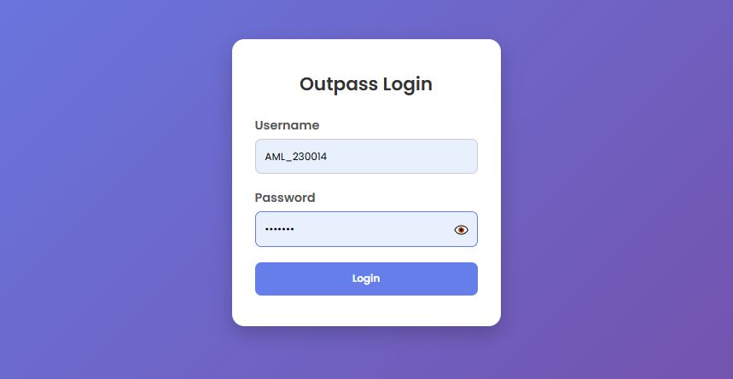
The login page serves as the entry point for all users of the Outpass Generator system. It is developed using HTML, CSS, and Flask, with form validation handled by JavaScript. The login page verifies user credentials against the MongoDB database and directs users to their respective dashboards based on role (Student, Approver, or Security). It incorporates security measures like password hashing and role-based redirection, ensuring that only authorized users can access protected functionalities. Invalid login attempts are handled gracefully with clear error messages.

Figure 7.1.1 Login Page

7.2 STUDENT DASHBOARD

The Student Dashboard provides an intuitive interface for students to request outpasses, view request history, and track the status of each request. It is designed with a clean UI using HTML and CSS, with real-time updates managed via JavaScript and Flask backend logic. Students can choose the leave date and reason, after which the request is forwarded to the approvers in sequence. Notifications about approval or rejection are sent through Flask-Mail. The dashboard also displays any auto-rejected requests due to past-date selection or policy violations.
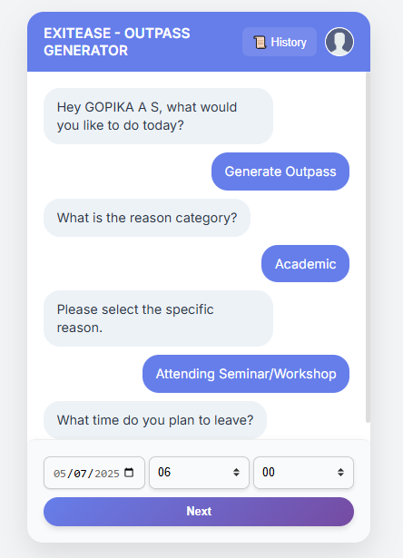

Figure 7.2.1 Student Dashboard

7.3 APPROVER DASHBOARD

The Approver Dashboard is tailored for faculty or staff members responsible for reviewing and acting on student outpass requests. It presents a list of pending, approved,irregular logs and rejected requests, along with options to approve, reject, or provide justifications. Flask manages the role-based access to ensure only assigned approvers see relevant requests. MongoDB stores all decisions and timestamps, and actions on this dashboard automatically trigger email notifications to students. The interface promotes efficiency and clarity in managing student movements.

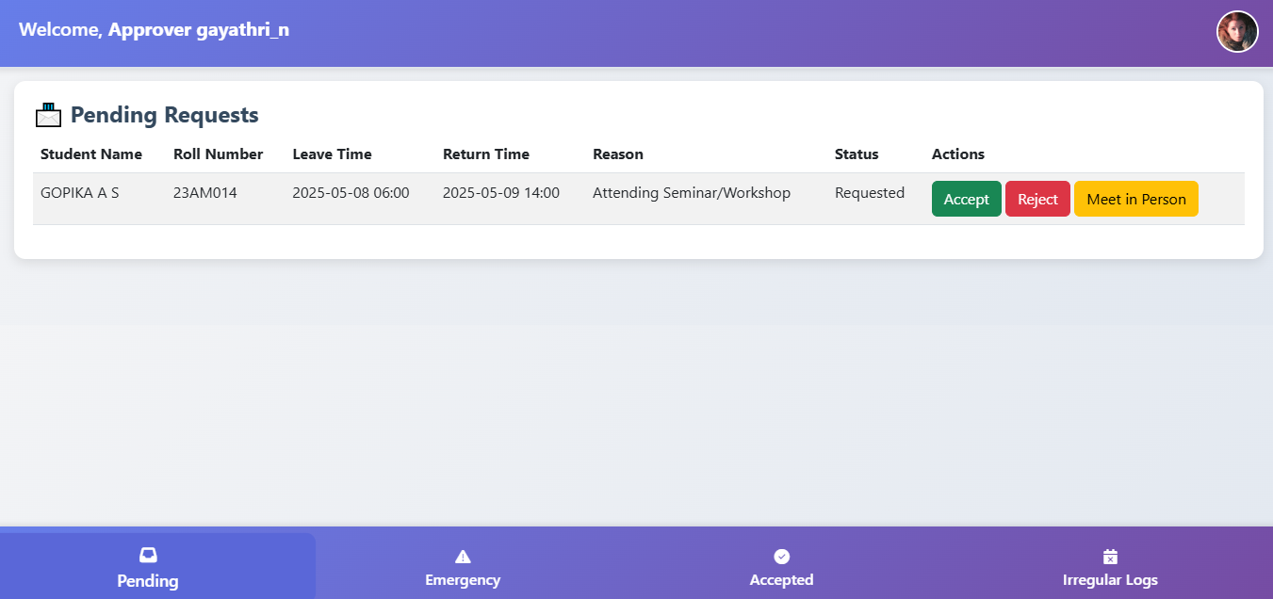
Figure 7.3.1 Approver Dashboard

7.4 SECURITY DASHBOARD

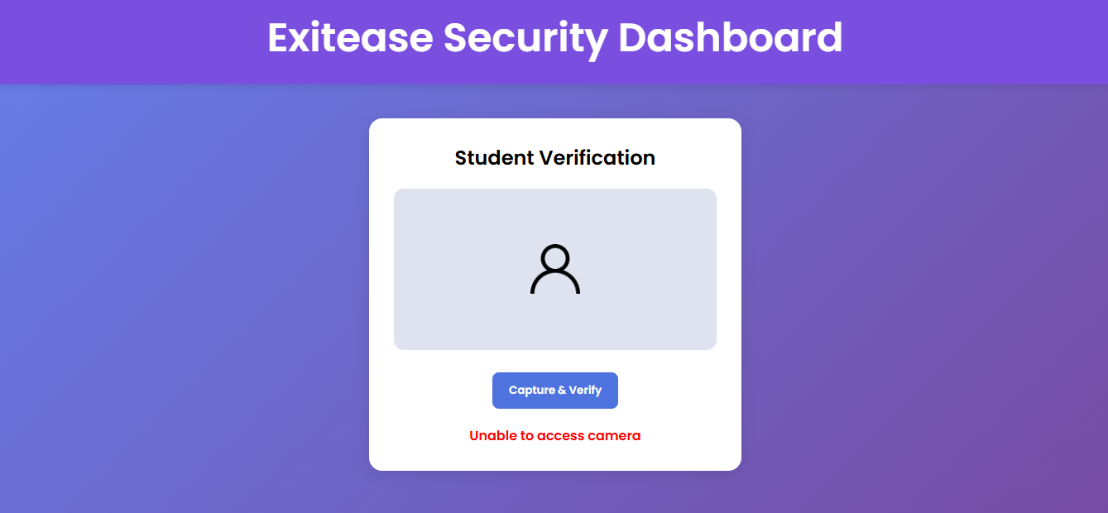
The Security Dashboard allows security personnel to verify the authenticity of approved outpasses. Security staff cannot modify requests but can only view validated approvals, ensuring a secure and accountable exit process.

Figure 7.4.1 Student Dashboard

CHAPTER 8

CONCLUSION AND FUTURE ENHANCEMENT

8.1 CONCLUSION

The Outpass Generator for Educational Institutions serves as a reliable and efficient platform that digitizes the traditional outpass system. By automating the request and approval workflow, the system reduces paperwork, eliminates delays, and provides a structured way to monitor student movements. With a role-based access mechanism, each user—students, approvers, and security personnel—has dedicated dashboards tailored to their responsibilities, ensuring smooth and secure interactions. The use of Flask for backend development enables fast and flexible response handling, while MongoDB ensures scalable data storage that adapts to the growing needs of the institution. The integration of Flask-Mail for real-time email notifications ensures timely communication, improving transparency and accountability in the approval process. Overall, the Outpass Generator provides a modern, user-friendly interface and strengthens institutional control over student mobility, improving campus safety and operational efficiency.

8.2 FUTURE ENHANCEMENT

To further strengthen the functionality and adaptability of the Outpass Generator, several future enhancements can be planned. A mobile application version can be developed to provide students and approvers on-the-go access and instant notifications. Advanced filtering options, such as auto-prioritization based on leave type or urgency, can improve decision-making for approvers. Integration with biometric systems or RFID scanners can add additional security layers at entry and exit points. Real-time data dashboards can help the administration monitor leave patterns, emergency cases, and policy compliance. Additionally, implementing multilingual support and accessibility features will make the system more inclusive. The chatbot feature can be enhanced with AI to provide natural language interaction, support FAQs, and handle more complex scenarios. These improvements will ensure that the system evolves with user expectations and institutional demands, maintaining its effectiveness and ease of use.

REFERENCES
[1] Grinberg, M. (2018). Flask Web Development: Developing Web Applications with Python. O'Reilly Media.
[2] Chodorow, K., & Dirolf, M. (2019). MongoDB: The Definitive Guide: Powerful and Scalable Data Storage. O'Reilly Media.
[3] Duckett, J. (2011). HTML and CSS: Design and Build Websites. Wiley.
[4] Flanagan, D. (2020). JavaScript: The Definitive Guide. O'Reilly Media.
[5] Ravichandiran, K. (2019). Flask Framework Cookbook: Over 80 Proven Recipes and Techniques for Python Web Development. Packt Publishing.
[6] Naqvi, S. A. G. R., Ansari, A. S., & Khokhar, M. K. J. (2019). "Web-based Management System for Educational Institutions: A Review," IEEE Access, vol. 7, pp. 138474–138489. DOI: 10.1109/ACCESS.2019.2934648.
[7] P. R. Kumar, A. Mehta, & D. Sharma (2021). "A Rule-Based Chatbot System for Automating Student Services," IEEE International Conference on Artificial Intelligence in Engineering and Technology (IICAIET), pp. 1–6. DOI: 10.1109/IICAIET51674.2021.9577087.
[8] R. Gupta, & S. Goel (2020). "Secure and Scalable Web Applications for Institutional Needs," IEEE Conference on Smart Technologies (EurAsia), pp. 142–147. DOI: 10.1109/EurAsia50169.2020.9216954.
[9] A. Sharma, & P. Jain (2022). "Design and Implementation of a Role-Based Access Control System in a College Web Portal," International Journal of Computer Applications, vol. 184, no. 4, pp. 25–3

